Cordapp Template Deployment Openshift

Pre Deployment:

1. Select project



1. Create a postgres instance for each corda node before deployment and note down the service names.
2. Create generic secret for certificates and configs for each corda node in network

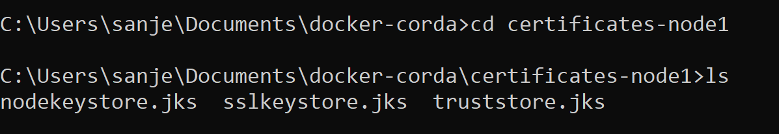

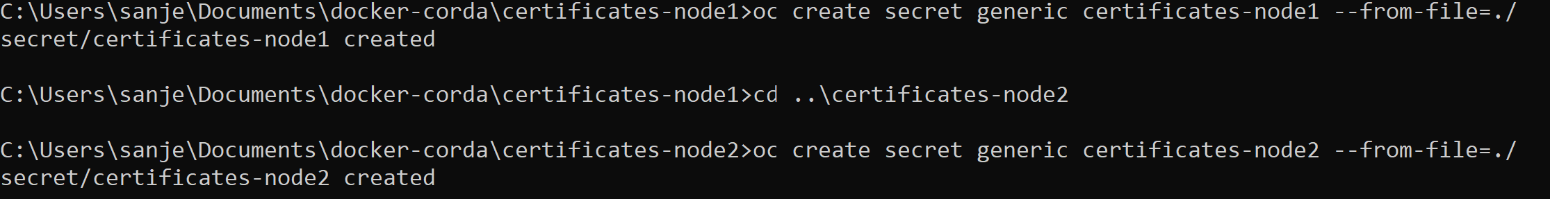

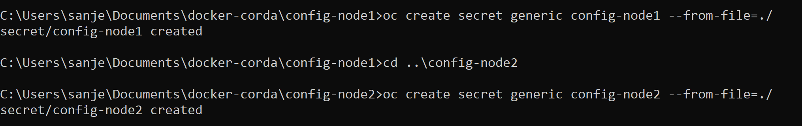

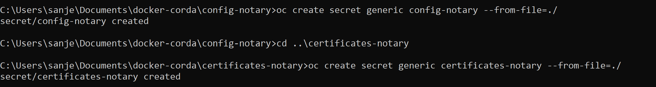

Note: The config file should use postgres service for postgres connection and corda service name in p2p address as shown below. Service names can be determined from template and project name.

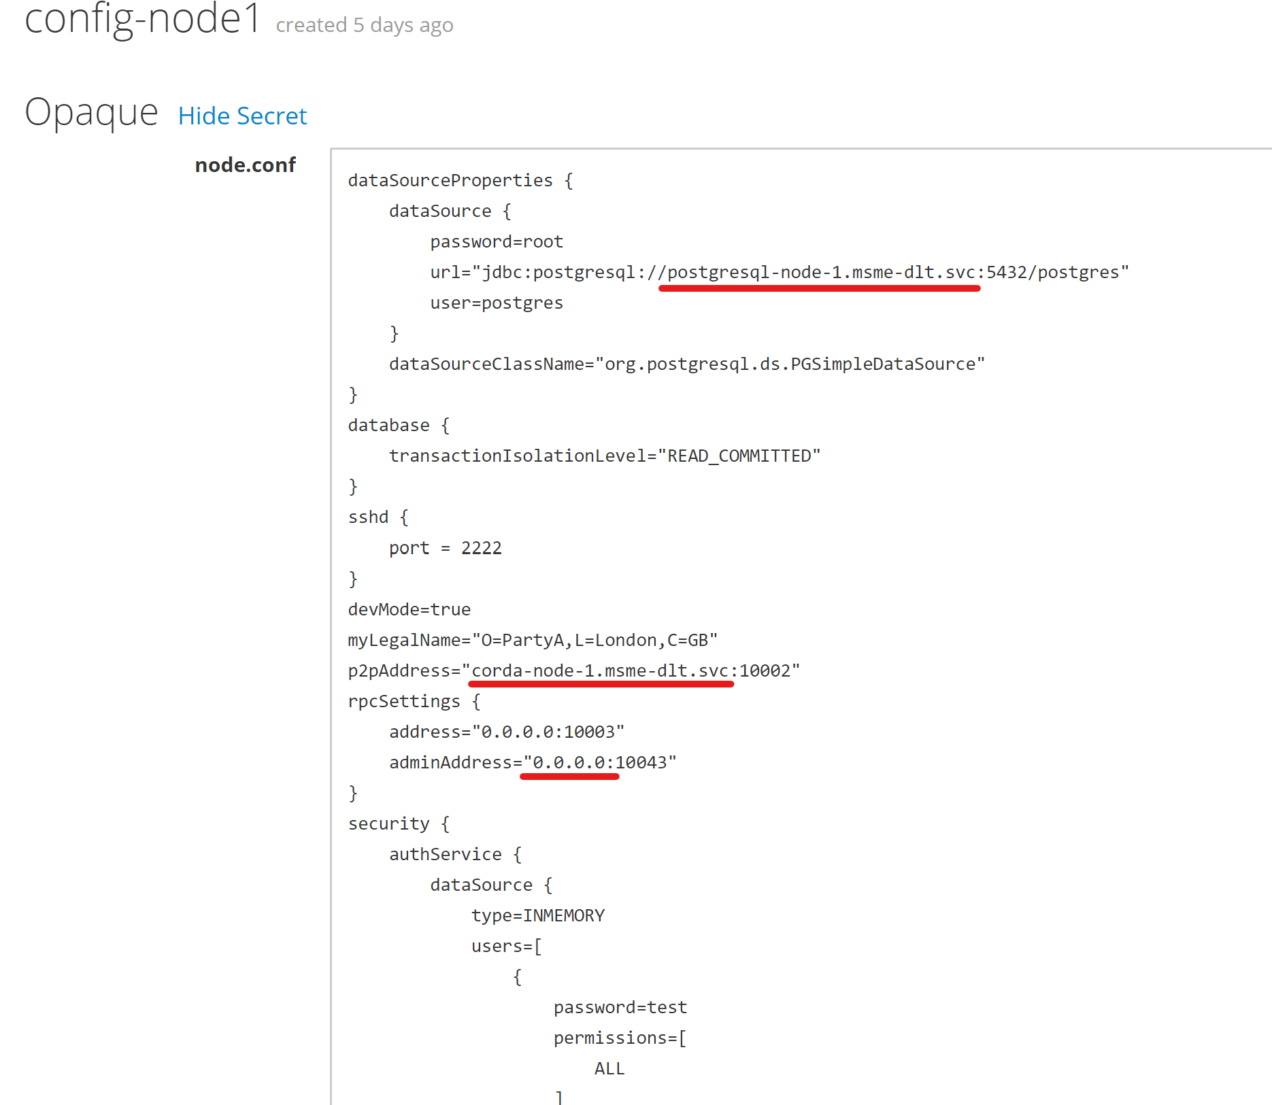

1. Create common secret for network parameter used by all nodes in network

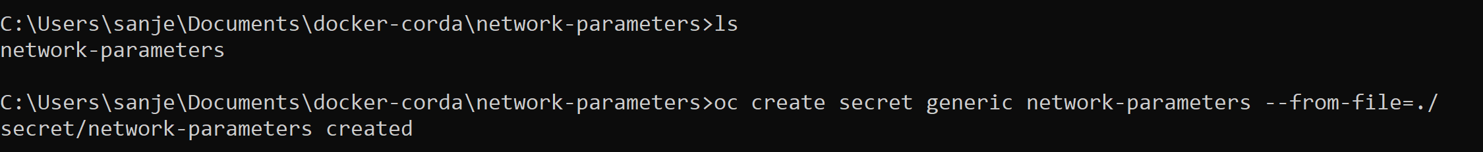

1. Create Storage to hold additional-node-infos and logs for each corda node

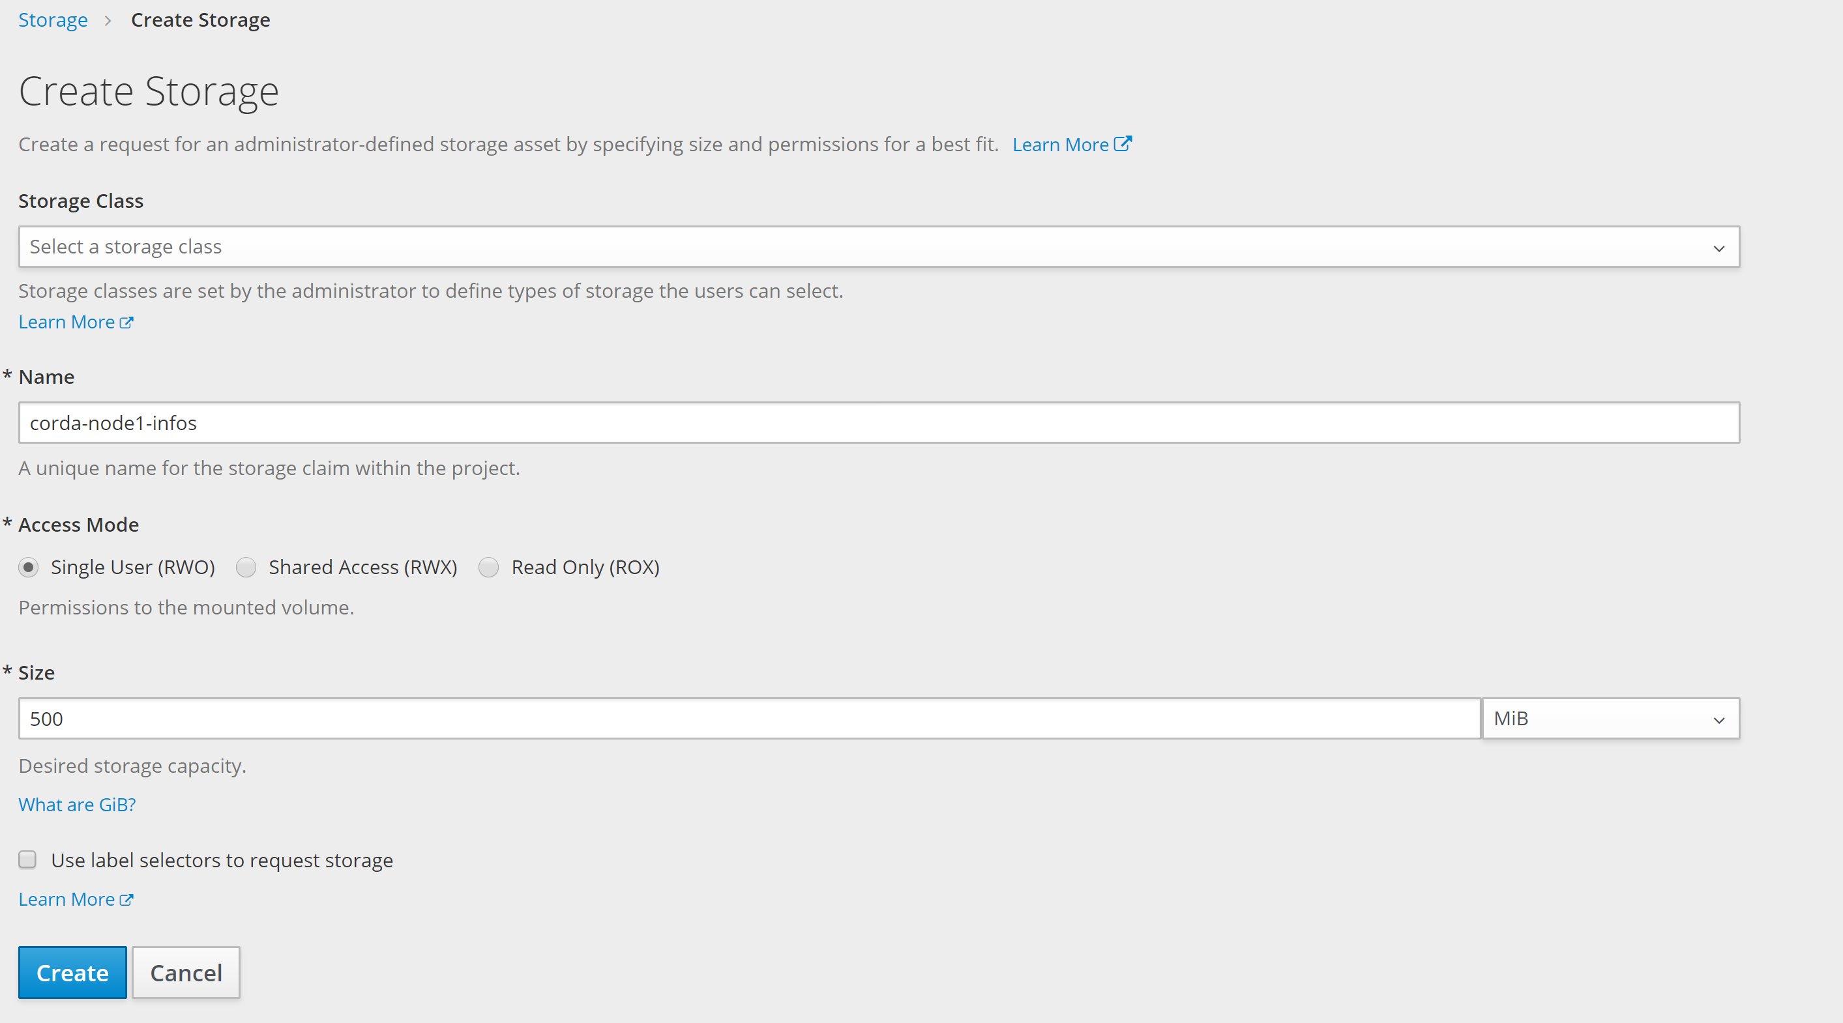

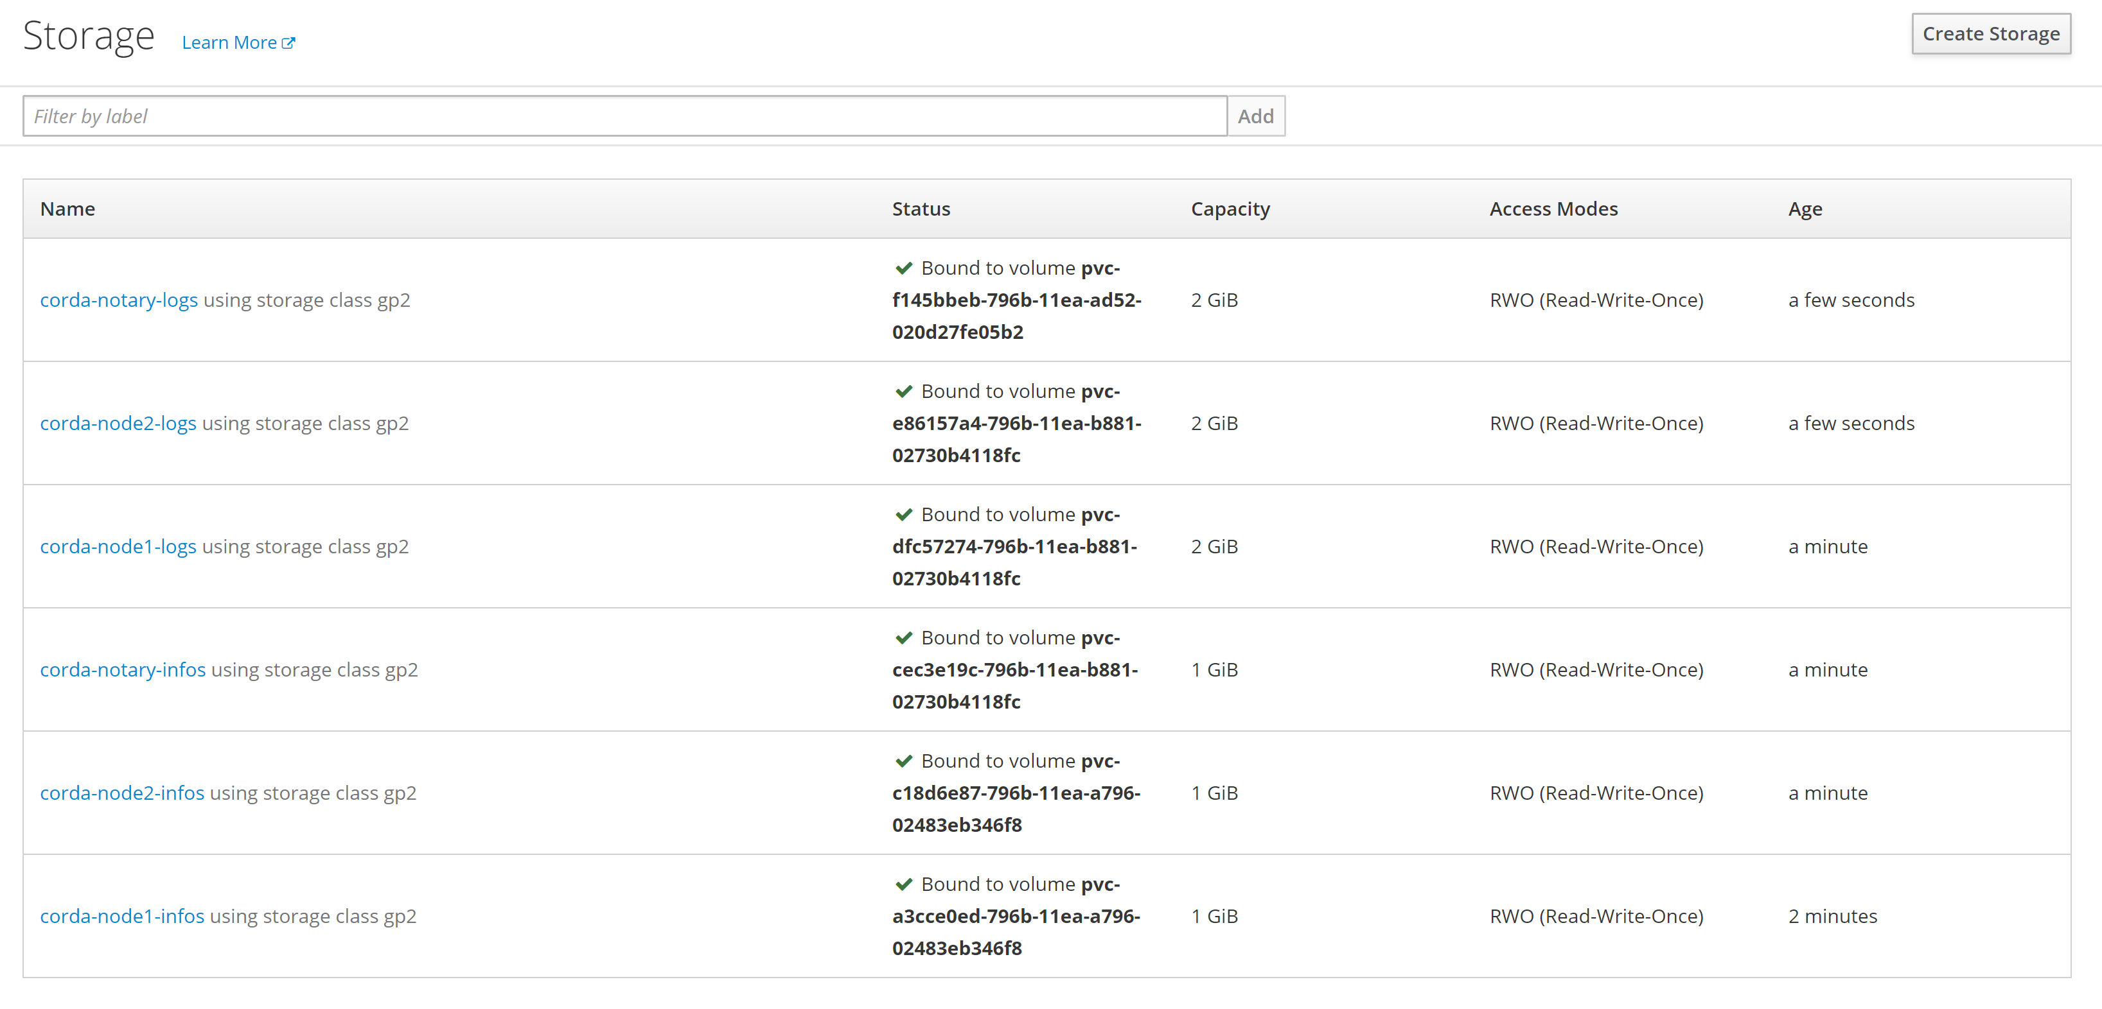

Build and Deployment:

All the necessary pre setup has been done.

1. Use the template available in projects git repository called **corda-build-node-template.json** and import in openshift project. This should build a docker image containing corda build, built from source code pulled from git

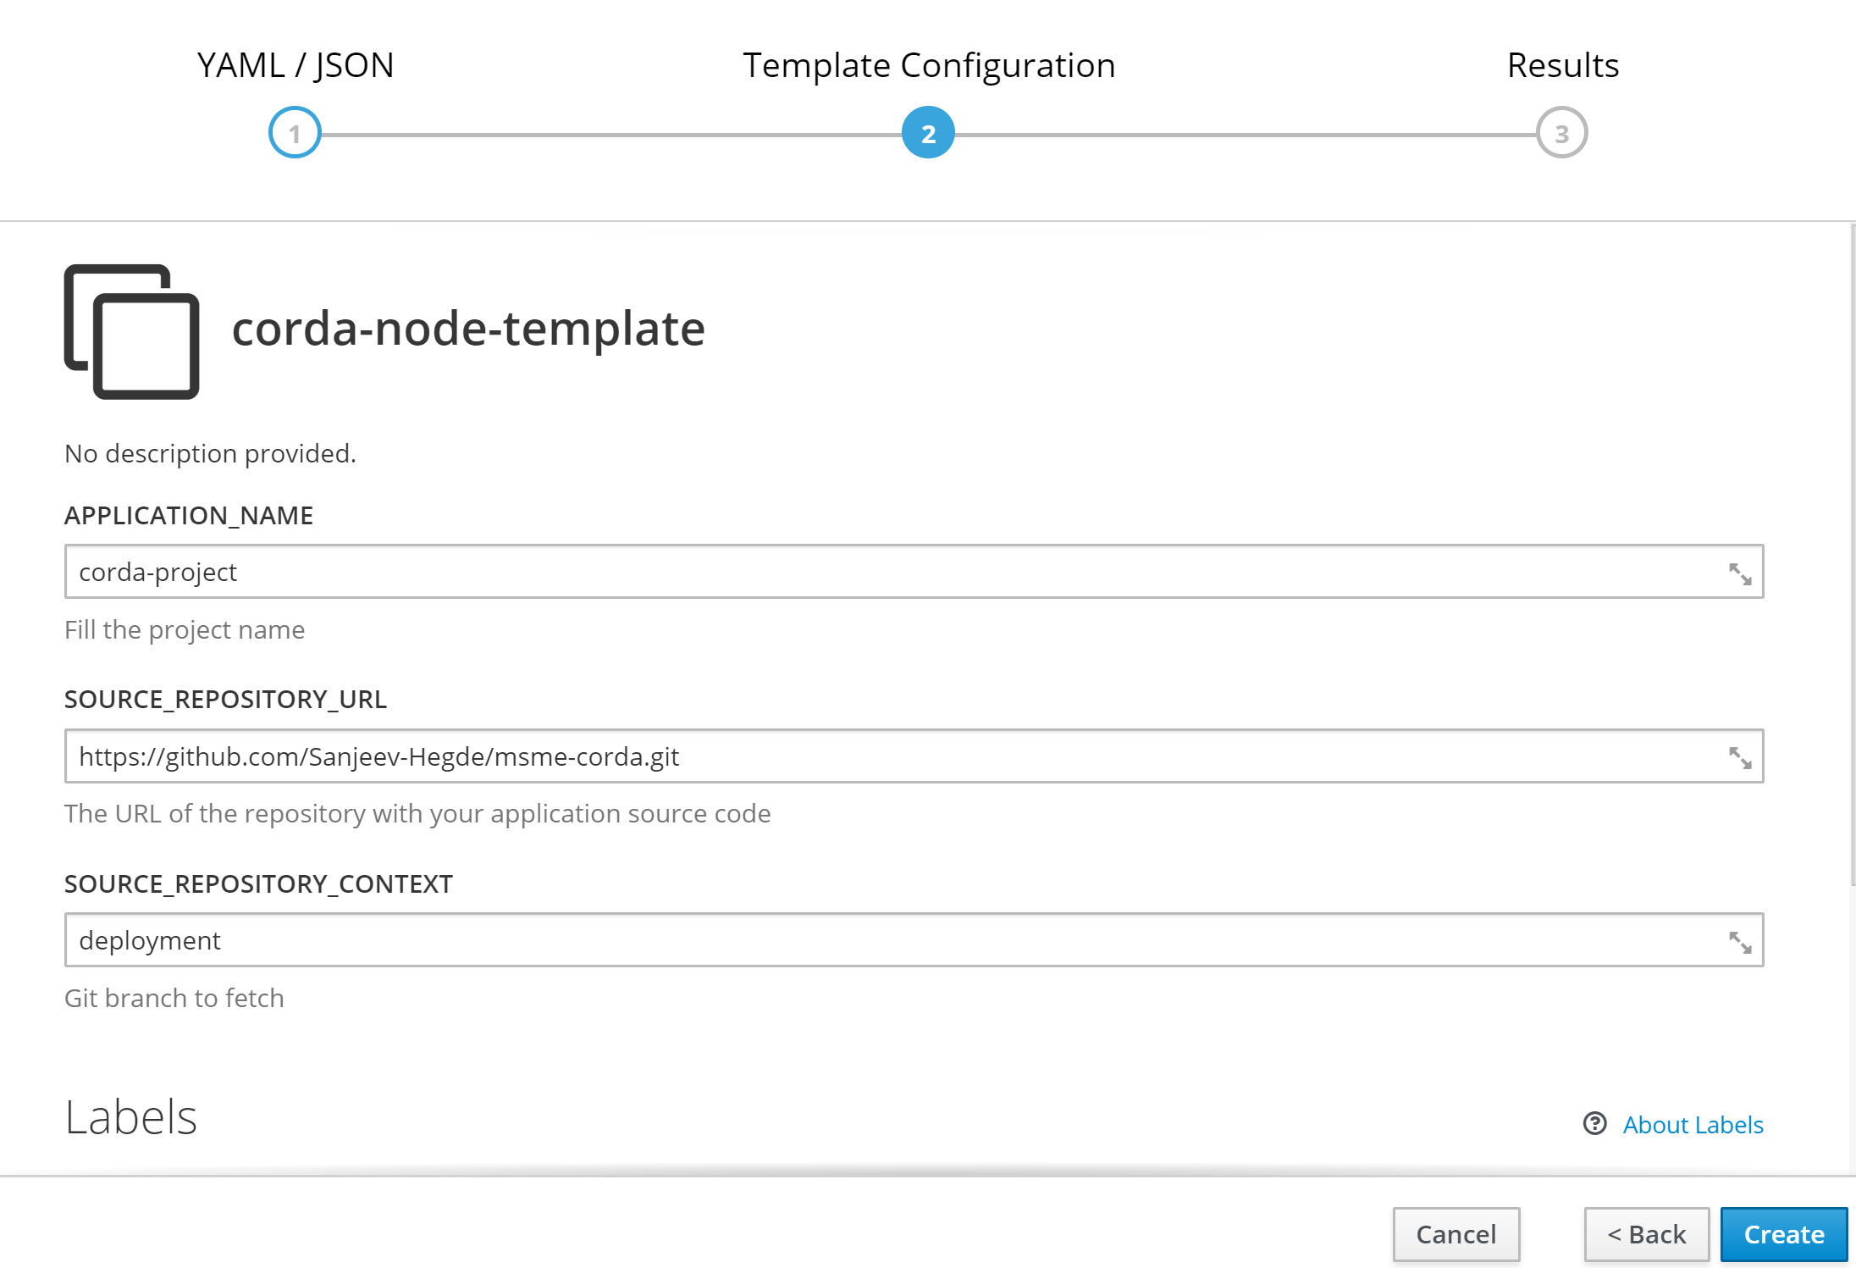

1. Once corda node is built, use deploy node template for corda deployment

The deploy template deploys the built image of corda node to a container. Fill the necessary secret names while using the deployment template as shown below

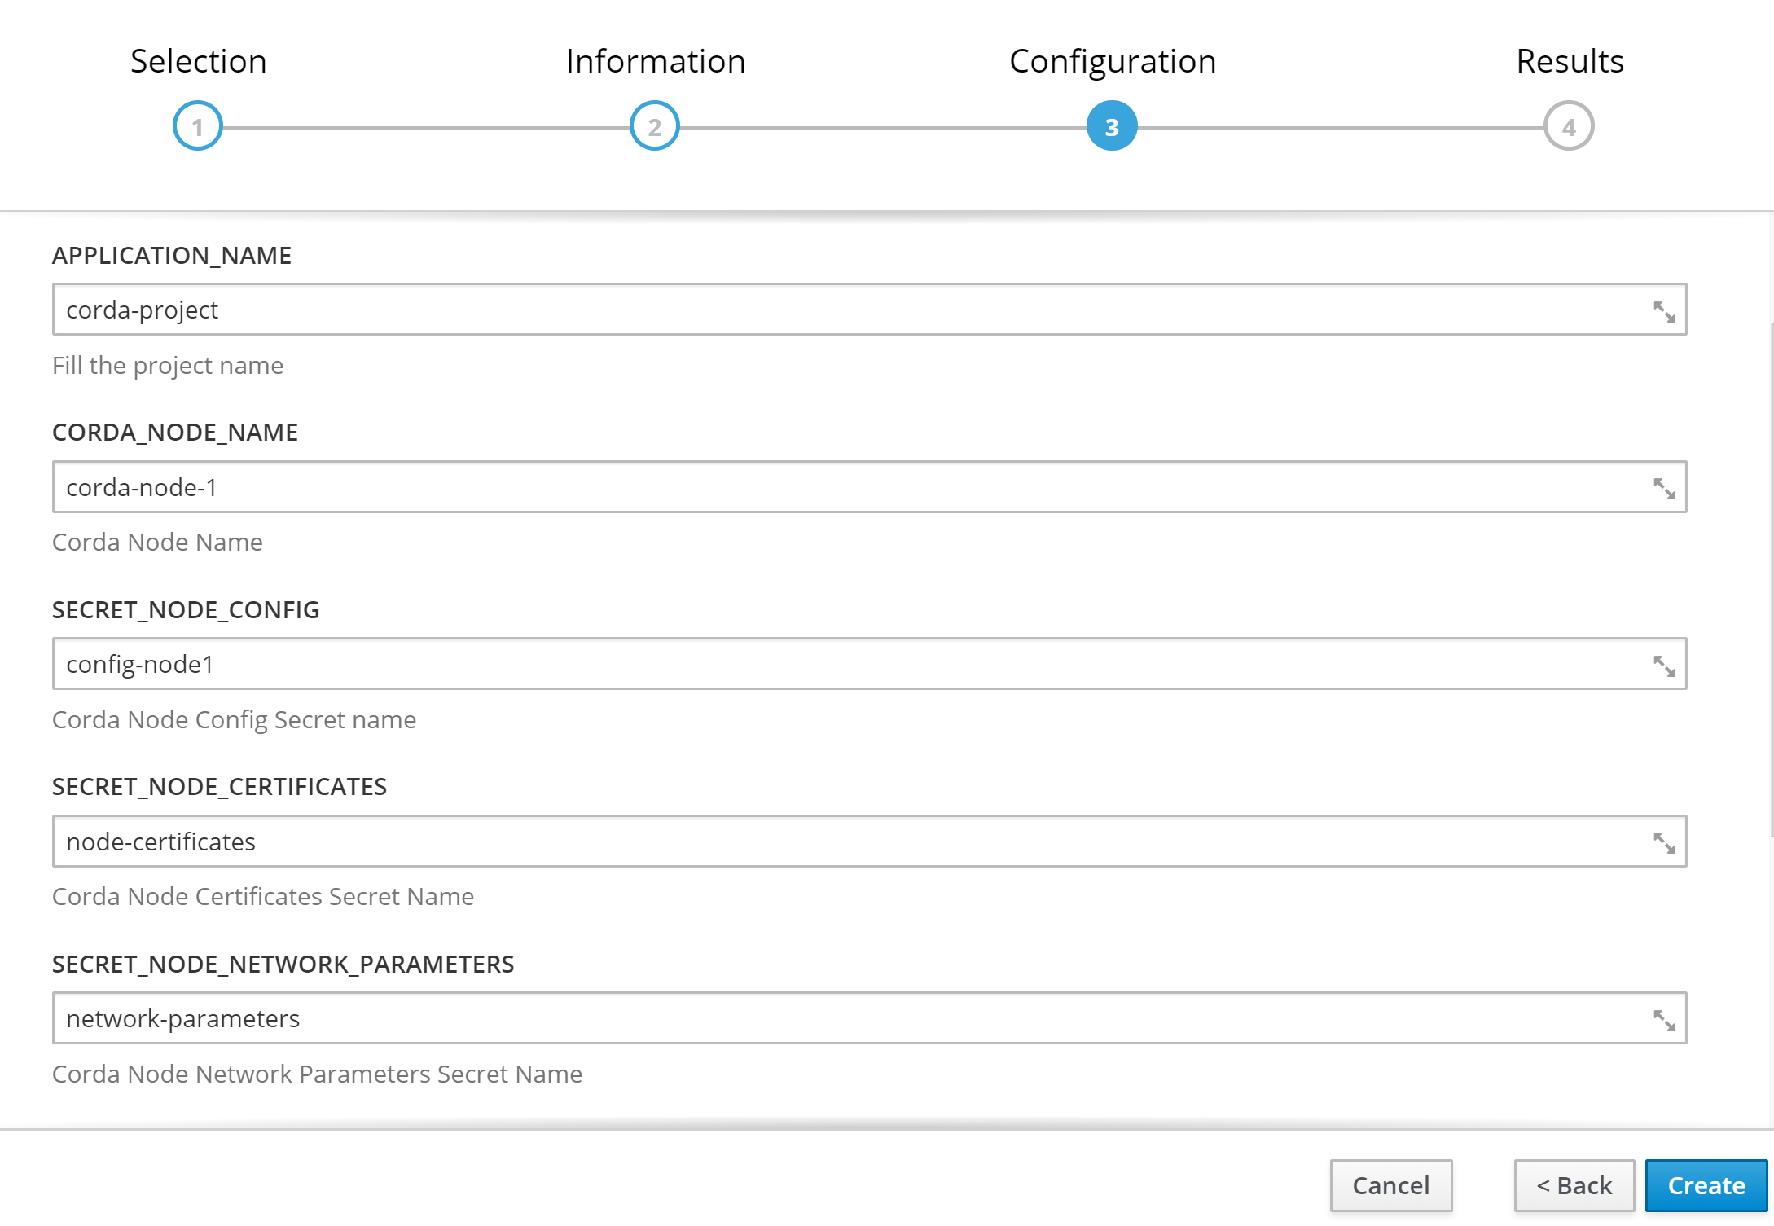

**Note:** Every time wheever corda node is built, it will deploy all nodes since all deployments use same image

Post Deployment:

1. SYNC ADDITIONAL NODE INFORMATIONS

Since this is not production ready node, its not connected to any network map services. So add othe node identity information’s manually after deployment

Create a new folder in your machine, go into that folder and do the following operations

**List the running nodes**

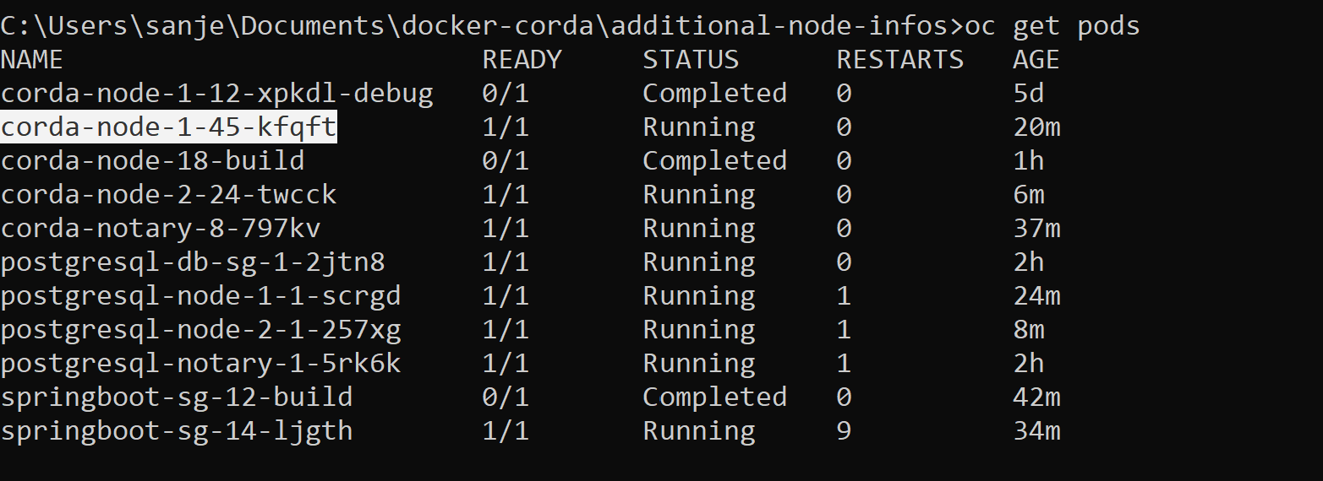

Copy all nodes node’s info to local directory



Sync all info’s in local directory with all nodes



This should make all nodes connect with each other